SEMINAR REPORT
College: SKR & SKR Govt. College for Women (A). Kadapa,
Seminar Topic: Entrepreneurship and Talent Management from a Global Perspective
Venue: SKR&SKR Govt.College for Women (A), Auditorium, Kadapa, Andhra Pradesh, India.
Participants: UG Ist, IInd and III rd year students
Name of the Resource Person: Dr.D.Rajesh Babu, M.com, M.B.A, Ph.D, Assistant Professor, Sanskrithi School of Business, Puttaparthi, Andhra Pradesh.
Date of Event: 23-11-2021, Time: 10:30 AM to 12:00 PM.

Mode: Offline

Coordinators: Staff Members

Profile of the Resource Person:
Dr.D.Rajesh Babu, M.com, M.B.A, Ph.D. in behavioural finance specialization, having 12 years of Teaching Experience as an Academician and worked various reputed institutions. Qualified AP-SET in Commerce, TS-SET in commerce and Qualified AP-SET in Management and Published 20 papers in various National and International journals, Having 6 years of Research experience on stock market investments, rational and behavioural attitude of investors on Indian stock market scenarios. His Area of interest for teaching and research in finance and Management contemporary issues. Having real-time investment experience on stock market-related investments, gained decent knowledge on fundamental analysis and technical analysis for investments in the stock market.
LinkedIn Profile: https://www.linkedin.com/in/dr-dasari-rajesh-babu-6b827515a
Email: rajeshdasari100@gmail.com

The theme of the Presentation:
Entrepreneurs are essential to any economy because they have the capabilities and initiative to anticipate needs and bring a few good new ideas to market. Entrepreneurship that succeeds in taking on the risks of starting a business is rewarded with revenues, fame, and chances for continued expansion.
Talent has become the most valuable resource applicable to various industries worldwide, including business, non-profit, and government. As they aim to get the upper hand in today's fast-changing market, these firms are now engaged in an increasingly tough race to obtain the most incredible people. Employees' attraction, selection, and retention are performed by HR activities that span the employee life cycle. Workforce planning, employee engagement, learning and development, performance management, recruiting, training, succession, and retention are all contained under this category.
Management skills are traits or talents that an executive should have to finish various jobs in a company. They include the ability/capability to carry out executive functions in a company. Organizational Structure, the organization of multiple segments or lines of business within a firm, is referred to as corporate Structure. Depending on the organization's aims and the industry, while avoiding crises and quickly resolving difficulties when they arise. Learning can help you build your management skills. Development of the Company Business development is the division within a company that makes strategic decisions about growing and restructuring the company, forming strategic partnerships, and gaining managerial experience. These abilities enable the manager to relate to their coworkers and know how to handle effectively with their subordinates, allowing the organization's activities to operate appropriately.

Takeaways by the students:

- Students understood various industry requirements in today scenarios
- Students understood the importance of entrepreneurship and talent management.
- Students understood future learning aspects to develop their career.
- Students understood concepts of talent management and skills enhancement in their career.
Photos of the Event

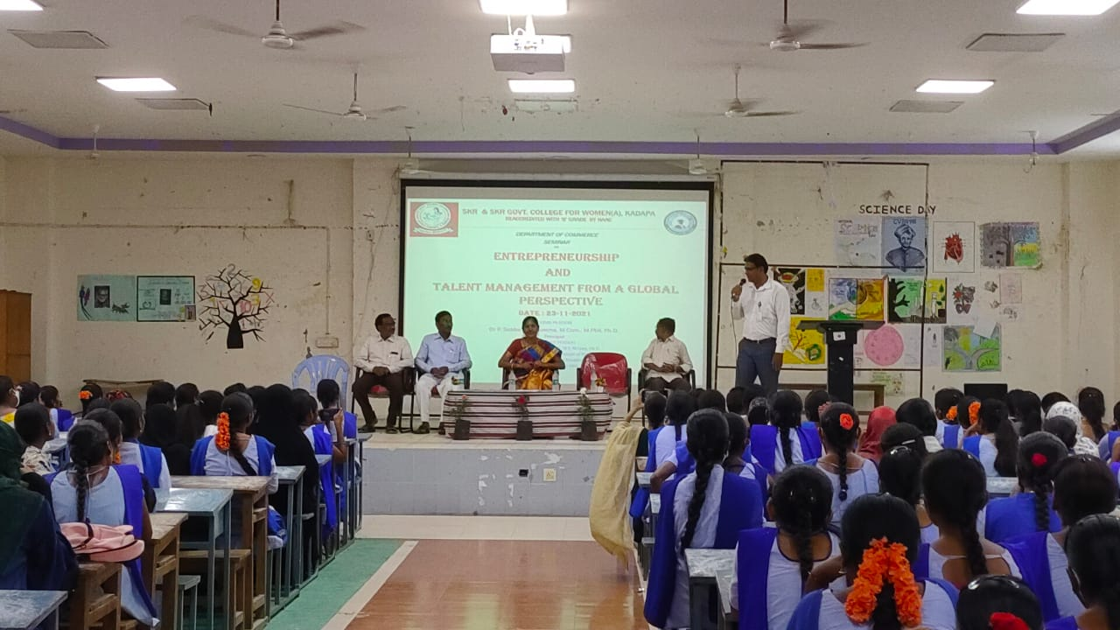

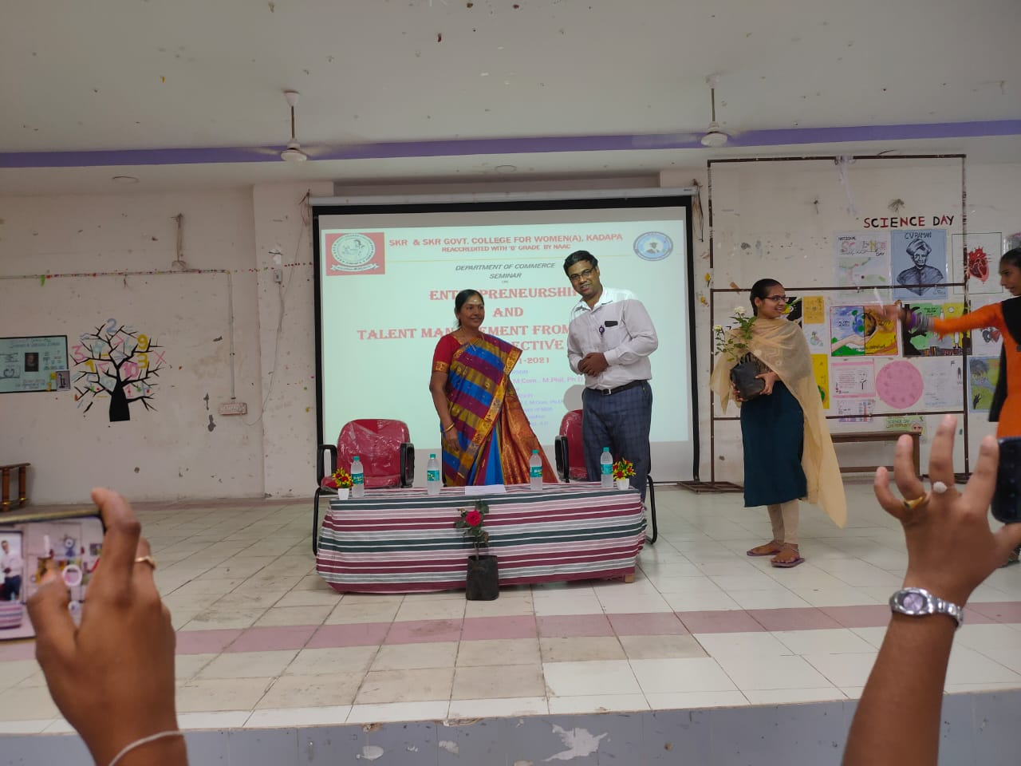

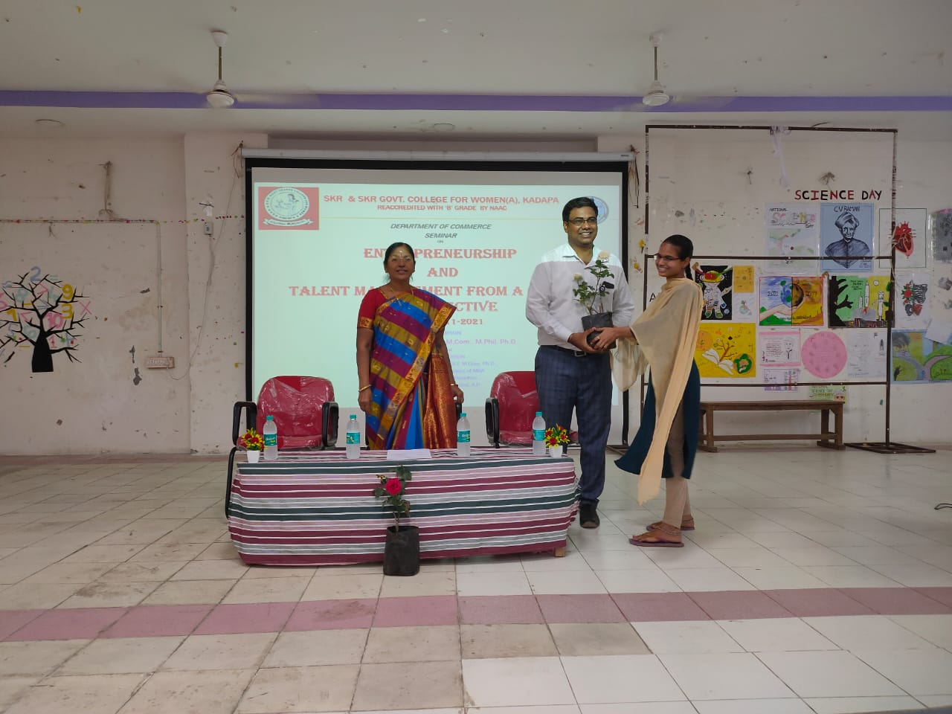

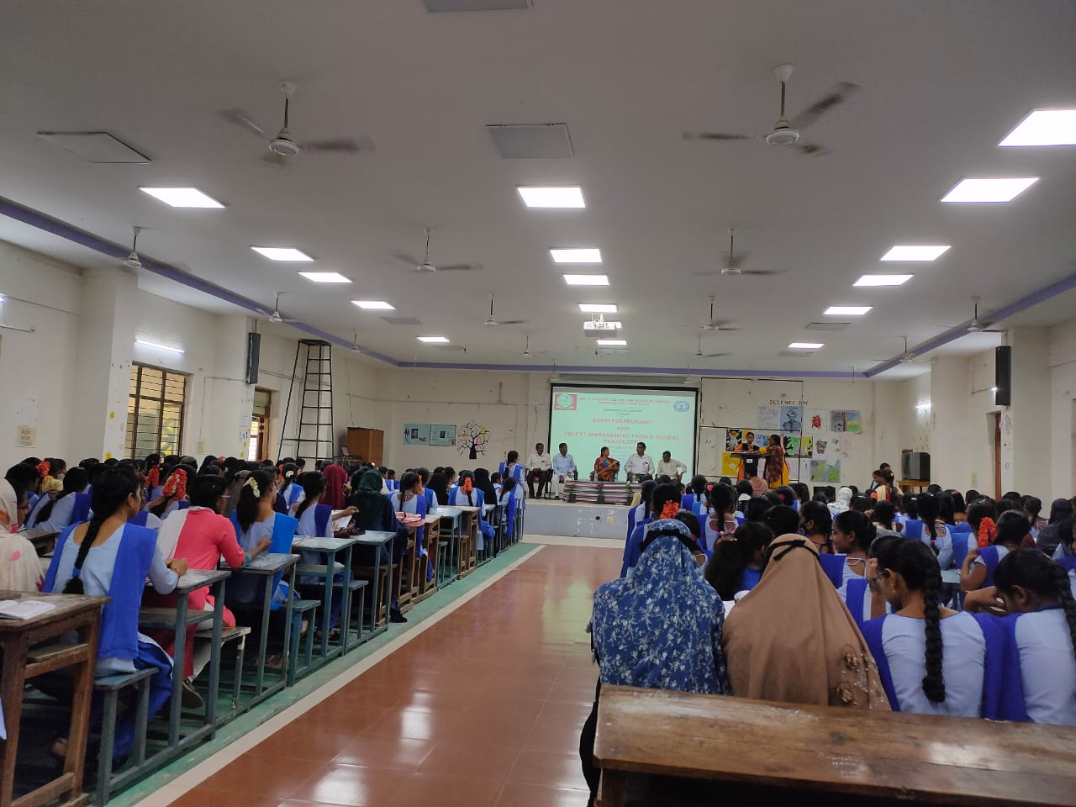

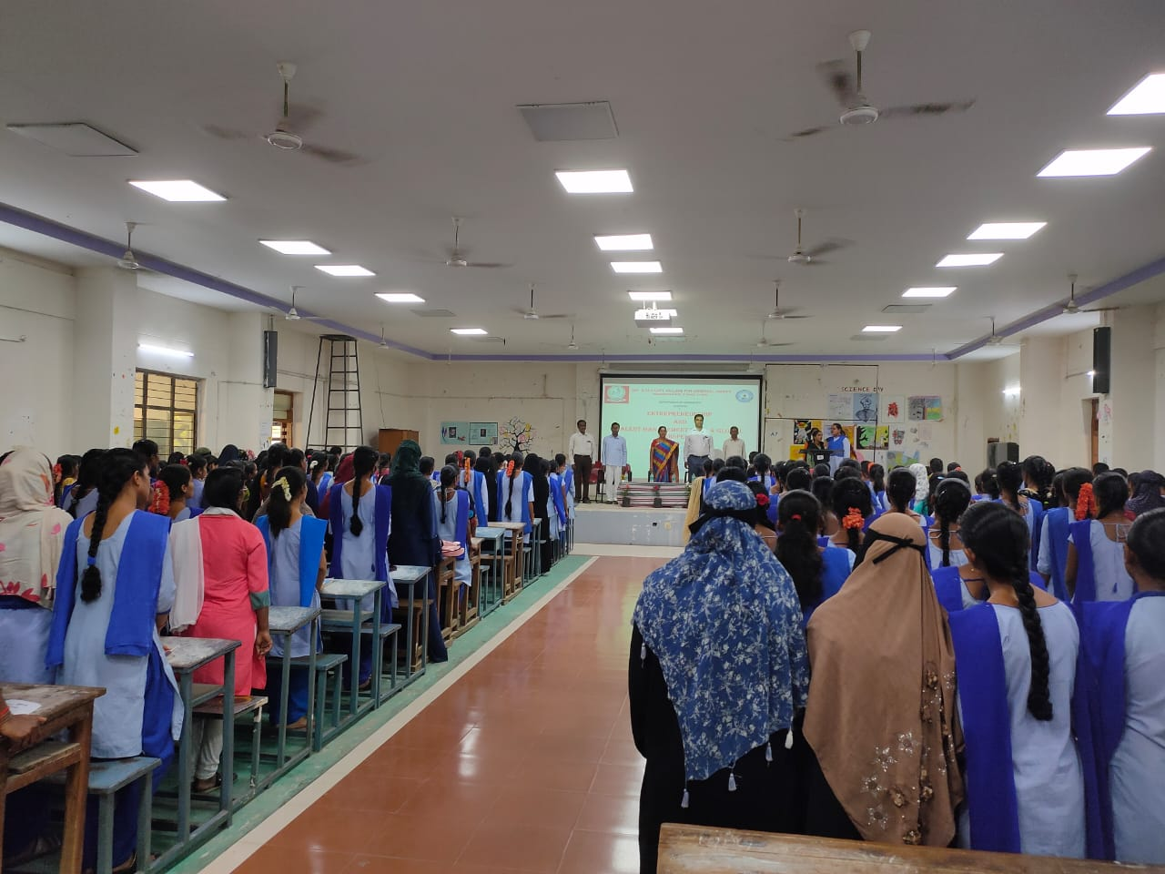

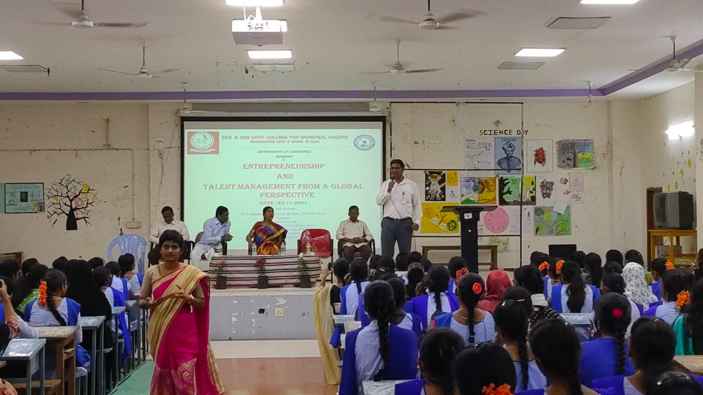

HOD PRINCIPAL

